Directions for Accessing Florida Electronic Library

Go to the home page of the library catalog
https://destiny.volusia.k12.fl.us/common/servlet/presenthomeform.do?l2m=Home&tm=Home&l2m=Home
In the list of Online Resources, click Florida Electronic Library
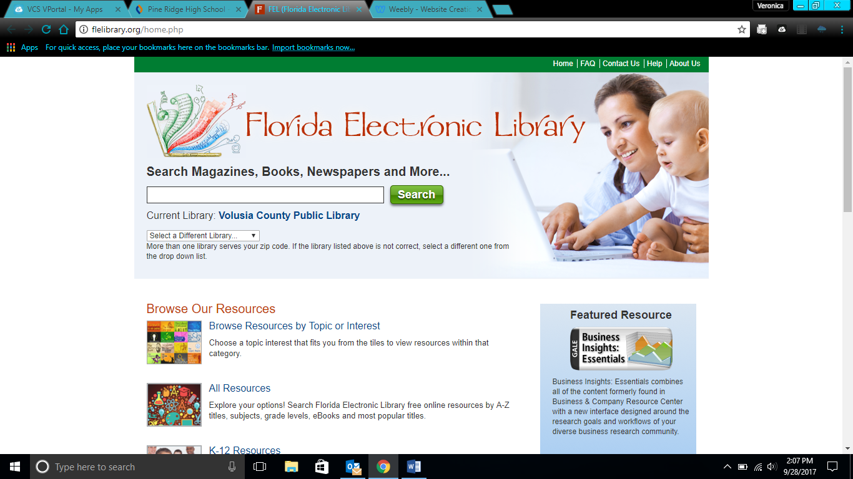

Once you are here, you have a variety of options:
- You can search right from the home page. Not something I would recommend as you will be wading through lots of things that you probably won’t use.
- Browse resources by topic—Not a bad idea but again you’ll get lots of stuff you won’t need
- K-12 Resources—This where I suggest starting.
  - Click K-12 Resources
  - Then choose the High School Tab
You will see that FEL and the Public Library have some of the same sources. You can access them from either source.
  - Once here, choose the database which best suits your needs

