Directions for accessing the databases of the Volusia County Public Library
Click on the link found on the media center webpage or the one below
http://volusialibrary.org/

Then, click on the link for the database login
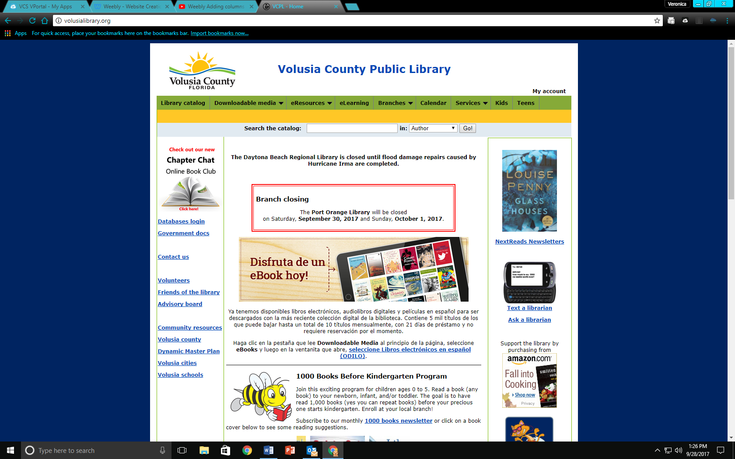

A sign in box will appear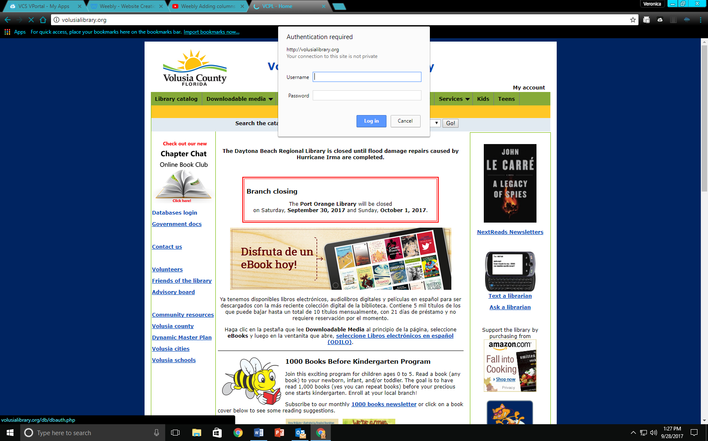
In the sign in box,
For Username 2241700
Leave the Password blank
Click log in

At this point you either do a general search or open the alphabetical list and search for a specific database.
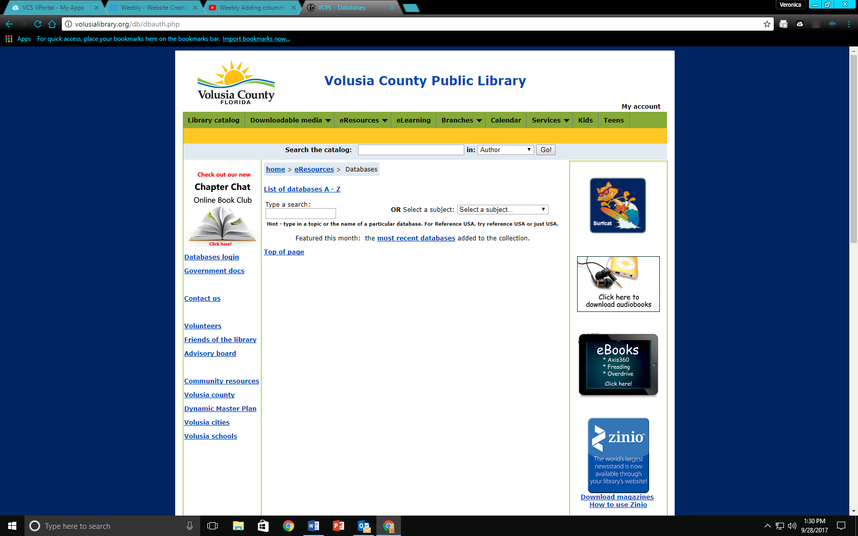
I suggest the alphabetical list because there are lots of databases and they can be very specific.

